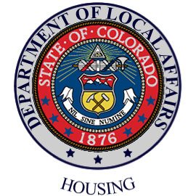

LANDLORD BULLETIN
COLORADO DIVISION OF HOUSING

The Colorado Division of Housing (DOH) would like to thank all Section 8 Rental Assistance landlords for providing housing to low-income families within the State of Colorado. Your continued participation in the program is greatly appreciated!

This is a REMINDER that your

JULY Housing Assistance Payments will be DELAYED!

- The July rental assistance payment checks will be delayed due to the State of Colorado’s fiscal year-end close on June 30th.
- Your rental subsidy check should be delivered no later than July 15th.
- If you do not receive your check by that date, please contact Julianna Nelson at (303) 866-5657.

Top Reasons Why Payments are Not Received

Listed below are the most common reasons landlords do not receive a rental subsidy payment:

- State Warrants are not forwarded. Therefore, if you change your address temporarily or permanently and don’t contact the housing agency, your payment will not be delivered.

- If you submit an incomplete or non legible W-9 form, the State Accounts & Control’s office will not register your W-9 in the state financial system. Therefore, all W9’s MUST be typed and signed.

- If your W-9 information does not match your tax ID information registered with the Internal Revenue Service, your payments will not be processed. Only one name is assigned to a tax ID. Please be sure the name on the W-9 and the Tax I.D. or TIN # coincides.
- Electronic Funds Transfer payments will be returned to the state if you change your bank account and don’t notify your housing agency.
- If you do not cash your state warrants in a timely manner. (State warrants expire six (6) months after issue date).
- If you do not return overpayments or fail to pay monies owed to another state agency. Section 8 payments may be held or reduced to satisfy outstanding debts to the state.

